ABSTRACT

Online Exam System is an application that is designed and developed for students and teachers. The system helps students to take examinations online. It also helps teachers to upload the questions and answers in the database and they can see the students who fail or pass the exam. The software is developed using Python programming language and Django.

In the software we can register as a user and users are of two categories which are Teacher and Student. Before using the system both users need to register and after that they must login with their username and password to enter the system. The online examination system is constituted of different components, for instance login function, insertion of data in the database, extraction of data from the database.

The problem with the current system is that students take their exam manually. This outdated system will take long time utilization; the manual procedure used for conducting exams is time consuming process. More time is being used for lecturers to bring the questions papers and answer sheets and more time is needed for students to write their exam.

INTRODUCTION

Computerized and online systems have been increasing in every aspect of education. Information Technology plays a very important role in education nowadays. Computers and internet have made dramatic changes in the education system. Information technology enables institutions of high learning to save time and money, and allow the delivery of education with easiness, anywhere, and anytime. Paper based books are replaced by online and off-line applications. With computer software, we can be able to have access to huge databases of information. This gives fundamental change to education. Information technology makes the exchange of information fast and easy. In the modern era, technological progress has minimized the information in the world. Advancement of technology has many advantages in education and all business industries that use it. With the use of technology advances, transactions became more rapid, accurate and efficient. As time goes by computers have become more useful for every transaction. Online Examination System for introduction to management is an application that is designed and developed for students and lecturers. The system helps students to take examinations. It also helps lecturers to upload the

Questions and answers in the database and they can see the students who fail or pass the exam.

SCOPE:

This project is aimed at developing an online examination system for introduction to

management for students and lecturers. The purpose of the system is to completely automate the old manual procedure of conducting exams to a computerized System. I will provide a more efficient examination system.

The system will allow students to register and take the exam. It also enables lecturers to perform many tasks. The system has several functions. The users will do the registration before using the system. The lecturers can upload questions and answers; he can view the list of all students who take the exam. He can view the list of students who have grade A, grade B, grade C, grade D and those who fail the exam. The lecturers can send emails. Once logging in, the students can choose the subject and take the exam. After finishing using the software, the users have a logout function that allows them to sign out. This is because the system wants to ensure no external users can exploit the system.

PROJECT DESCRIPTION:

In the contemporary educational landscape, traditional teaching methods often struggle to captivate and engage students effectively. Passive learning approaches, such as lectures and textbooks, may fail to cater to diverse learning styles and preferences, resulting in disengagement and suboptimal academic performance. Consequently, there is a pressing need to address this issue by leveraging innovative technologies and pedagogical strategies to create interactive learning environments that foster student engagement and improve learning outcomes.

SYSTEM ANALYSIS:

Analyzing the distribution system of pharmaceuticals medicinal products involves understanding the various stages, stakeholders, challenges, and regulatory requirements involved in getting these products from manufacturers to end-users. Here's a systematic analysis:

Manufacturing: Pharmaceutical products are manufactured in facilities adhering to strict quality standards and regulations. This involves the synthesis of active pharmaceutical ingredients (APIs) and their formulation into finished products.

Packaging and Labeling: After manufacturing, products are packaged and labeled appropriately. This step ensures proper identification, dosage information, and compliance with regulatory standards.

Distribution Centers: Pharmaceutical products are typically stored in distribution centers strategically located to serve various regions efficiently. These centers manage inventory, order processing, and shipping logistics.

Transportation: Products are transported from distribution centers to wholesalers, pharmacies, hospitals, and other healthcare facilities. Temperature-controlled transportation is often crucial, especially for products requiring cold chain management.

Wholesalers: Wholesalers act as intermediaries between manufacturers and retailers. They purchase large quantities of pharmaceutical products and distribute them to pharmacies and healthcare facilities.

Pharmacies and Dispensing Points: Pharmacies play a critical role in the distribution chain as they dispense medications directly to patients. They must comply with regulations related to storage, handling, and dispensing of pharmaceuticals.

Healthcare Facilities: Hospitals, clinics, and other healthcare facilities procure pharmaceutical products for patient treatment. They may have their distribution systems or rely on wholesalers and pharmacies for supply.

Regulatory Compliance: The pharmaceutical distribution system is highly regulated to ensure product safety, efficacy, and quality. Regulations govern manufacturing practices, labeling, transportation, storage, and distribution processes.

Quality Assurance: Quality control measures are implemented at every stage of the distribution process to prevent contamination, counterfeiting, and other quality-related issues. This includes batch testing, monitoring temperature conditions, and inspecting packaging.

Technology and Automation: Advancements in technology, such as track-and-trace systems and inventory management software, have improved efficiency and transparency in pharmaceutical distribution. Automation helps streamline processes and reduce errors.

Challenges: The pharmaceutical distribution system faces various challenges, including counterfeit drugs, regulatory complexities, supply chain disruptions, and the need for maintaining cold chain integrity, especially for biologics and vaccines.

Global Distribution: Many pharmaceutical products are distributed globally, which adds complexity due to differing regulatory requirements, cultural factors, and infrastructure limitations in various regions.

Emergency Response: During emergencies such as pandemics or natural disasters, the pharmaceutical distribution system must be resilient and adaptable to ensure the timely delivery of essential medications to affected areas.

Sustainability: There's a growing focus on sustainability in pharmaceutical distribution, including reducing carbon emissions from transportation, minimizing packaging waste, and optimizing supply chain efficiency.

By systematically analyzing each aspect of the pharmaceutical distribution system, stakeholders can identify opportunities for improvement, address challenges, and ensure the safe and efficient delivery of medicinal products to patients.

#### **LITERATURE SURVEY**

**Background of the study**

Computerized and online systems have been increasing in every aspect of education. Information Technology plays a very important role in education nowadays. Computers and internet have made dramatic changes in the education system. Information technology enables institutions of high learning to save time and money, and allow the delivery of education with easiness, anywhere, and anytime. Paper based books are replaced by online and off-line applications. With computer software, we can be able to have access to huge databases of information. This gives fundamental change to education. Information technology makes the exchange of information fast and easy. In the modern era, technological progress has minimized the information in the world. Advancement of technology has many advantages in education and all business industries that use it. With the use of technology advances, transactions became more rapid, accurate and efficient. As time goes by computers have become more useful for every transaction. Online Examination System for introduction to management is an application that is designed and developed for students and lecturers. The system helps students to take examinations. It also helps lecturers to upload the questions and answers in the database and they can see the students who fail or pass the exam.

**Examples of Exam Systems**

##### Infosolutions Goa

They provide an online Examination System to universities. It is a web-based system developed in PHP and MySQL. The examination consists of different types of multiple choice questions. The questions are selected at random keeping the proper weightage for the various topics. The answers are evaluated and the marks obtained for each along with the answer given by the student are stored in the database. The examiner can get the results immediately in various forms - the general mark list, the detailed general mark list where the marks obtained by the student in each topic of the subject is shown as well as the answer sheet of each student. The trends graph show the graph of how many students have passed in each topic of a particular subject as well as how many students have passed in each subject. There is also the provision for a Trends graph of comparing how many students have passed topic wise in each subject at the midterm as well as final exams if there are two exams for the subject.

The software maintains the details for each student as well as provides a facility for editing

the student details if required. There is Password based access for Individual Answer Sheet, General Mark Lists and Trends Graphs. Authentication is provided Via Sessions and the password is stored in encrypted form (MD5 hash) in the database.

This Online Examination System in PHP and MySQL can be modified and customized to suit the needs of any Educational Institutions, Primary and Secondary Schools, Colleges, Professional and Vocational Institutes, Universities or Training Academies. This software is particularly suited to conduct competitive exams like recruitment exams and Common Entrance Tests (CET) of various states as it will save valuable time spent on assessing the answer books and the results can be obtained immediately.

##### iSummation Technologies

This company builds custom online exam creation and administration applications. It’s fully automated web-based examination software. The features of the software are customizable, students can do online registration. In the software they are Automated test creation randomized questions, Centralized administrator controls , In built Question database for exam questions, Access anywhere, anytime Application, Exam Format intuitive and easy to navigate ,Administrators load the questions into the database, Examinations are generated automatically as per student selections, Exams and questions can be edited, deleted, and re-used anytime, A discussion board feature so that the students can discuss problems that challenge them, Add answers hints.

FEASIBILITY STUDY:

##### **Technical Feasibility**

Building this system is technically feasible. The hardware and software needed are all

available, it is not difficult to get them. Brief I can say the necessary resources needed for the

development and maintenance of the system are available. I am going to use python programming languages and SQLite database.

##### **Operationally Feasibility**

The project I am developing is operationally feasible as there is no need for users to

have good knowledge in computer before using it. The user can learn and use the system with easiness; he just needs to read the manual or tutorial from the developers.

##### **Economic Feasibility**

Besides being technically feasible, developing this system is economically feasible as

well. The development of the system does not require the developers to spend a lot of money. The tools I will be using to develop the system are not expensive and the software is open source. All I need is time. Even the maintenance of the system will not be expensive. The system is indeed economically feasible.

HARDWARE AND SOFTWARE REQUIREMENTS:

**1. Hardware Requirement:**

o CPU: Intel Pentium (Dual Core) and above  o Memory: 2 GB RAM o Internal: 60 GB

**2. Software Requirement:**

o Windows 7 Professional (32 bit) and above.

o Development Language: Python, JavaScript, CSS, HTML

o Database : SQLite o Server : Apache (XAMPP)

**3. Software Specification:**

**HTML:**

* HTML stands for Hypertext markup language.
* It is the collection of many tags which are used to give the structure of a webpage (skeleton of a web-page). tags are written in between angular bracket(i.e<>).

**CSS:**

* CSS stand for cascading style sheet.
* It is used to add style , border ,colours etc. to the existing webpage which is created by html.
* It can be written in 3 different ways inside the html file(inline , internal and external style).

**JAVASCRIPT:**

* JavaScript is used to provide user interface with web-page that means it is used to implement dynamic interaction with webpage.it is scripting language which contain a collection of scripts.
* It is used to provide the functionality of webpage and it is similar to the python language because both are scripting language.

Conclusion:

The successful implementation of virtual learning environments in college settings requires careful consideration of hardware and software requirements to ensure optimal performance, accessibility, and user experience. By investing in the necessary resources and infrastructure, colleges can leverage VLEs to enhance teaching effectiveness, promote student engagement, and facilitate flexible learning opportunities in the digital age.

#### **DESIGN APPROACH**

Design is the first step in the development phase for any techniques and principle for the purpose of defining a device, a process or system in sufficient details topermits its physical realization.

**Use case diagram:**

The unified modeling language used is use case diagram. A use case is a set of scenarios that describes an interaction between a user and a system. A use case diagram displays the relationship among actors and use cases. The two main components of a use case diagram are use cases and actors. The actors in our system are students and lecturers. The use case diagram is designed in the following figure.

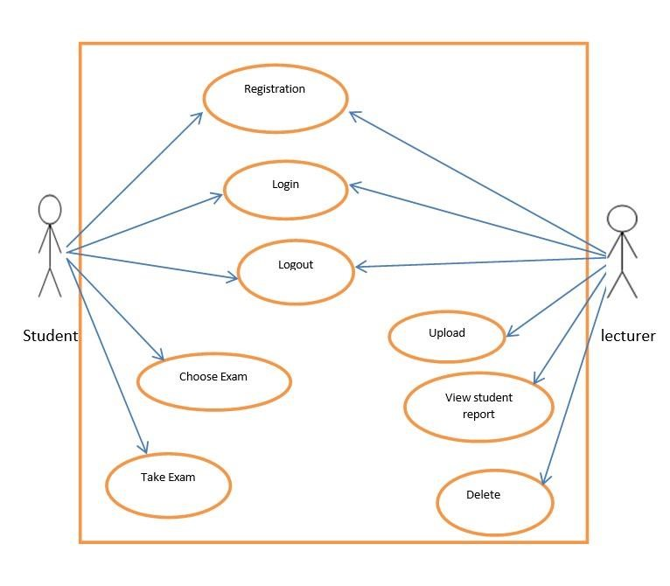

**System flow chart:**

A system flowchart is a valuable presentation aid because it shows how my system major

components fit together and interact. In effect, it serves as a system roadmap.

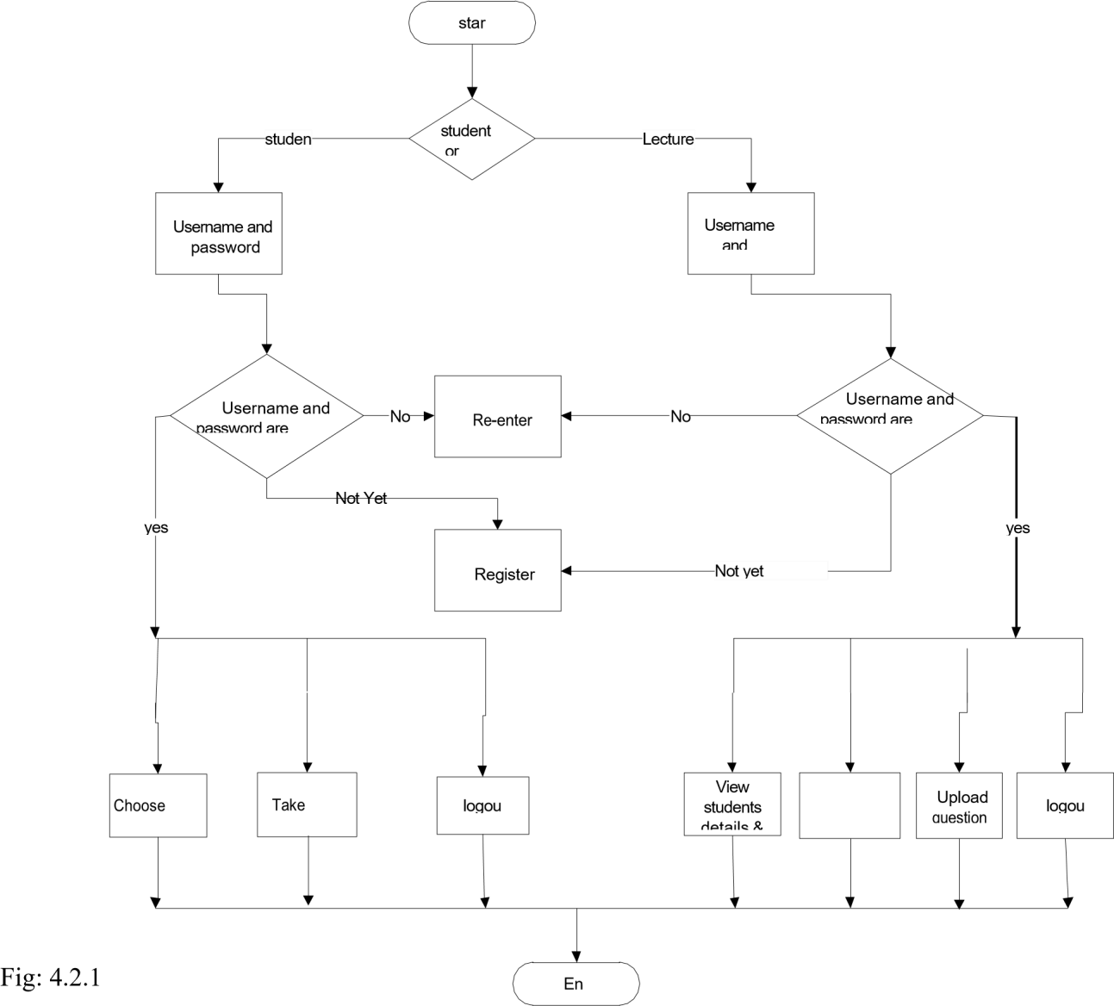

**Entity**



**Relationship**



**Diagram**

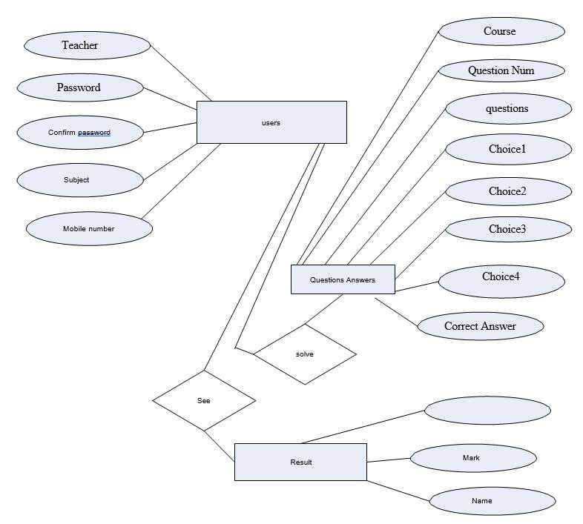

**Context Diagram:**

The Context Diagram shows the system under consideration as a high-level process and then shows the relationship that the system has with other external entities.

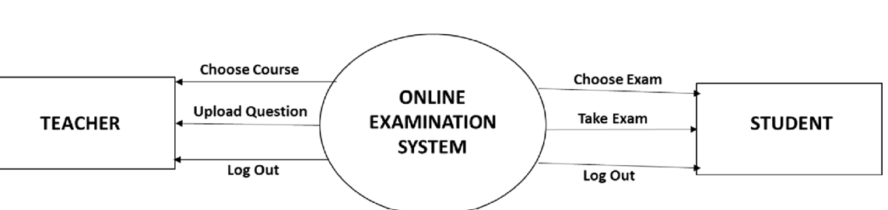

**Key Milestone:**

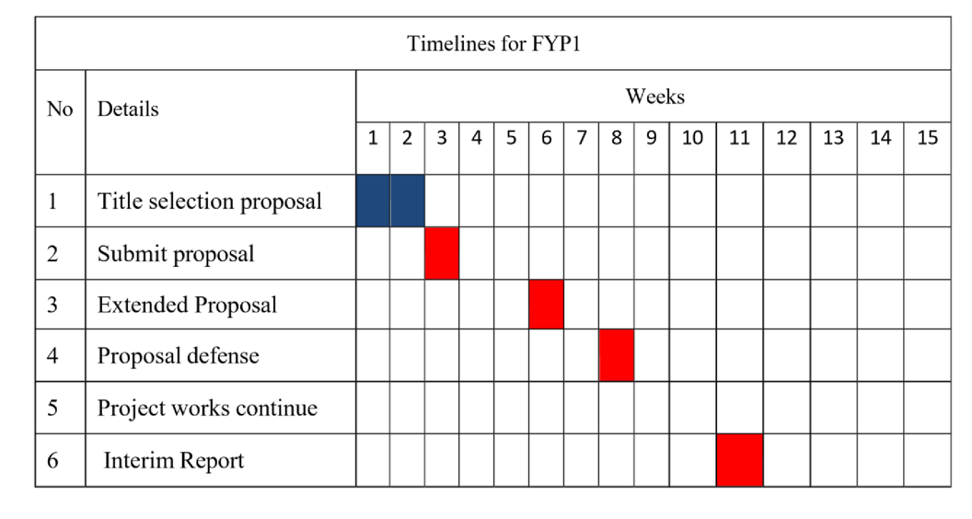

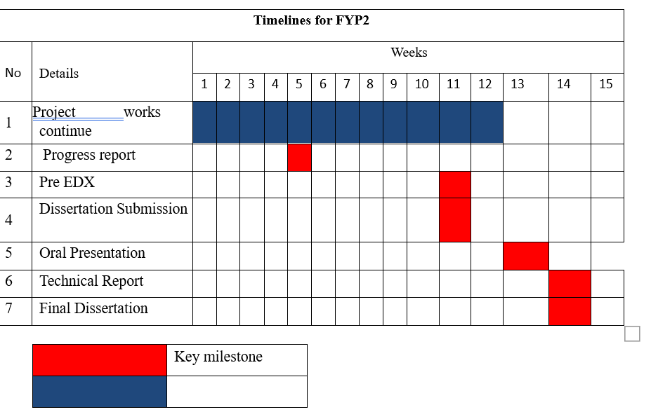

#### **METHODOLOGY**

**Research Methodology**

Main methodology activities held during the research is acquiring information and knowledge about online examination system through reading books, and researches that were previously done in related area. All the research materials were obtained over the internet, Wikipedia and other websites.

Next step taken is reading, comprehending and analyzing literature review and matching information obtained. This research emphasize online examination system, which include usability, user-friendly interface, reliability, costing and meeting needs of target users.

**Project Activities**

In order to give solution to problems in an industry, software developer or a team of developers must incorporate a development strategy that encompasses the process, methods and tools layers and generic phases. This strategy is often referred to as process model or a software developing paradigm. A process model for software developing is chosen based on the nature of project and application, the methods and tools to be used, and the controls and deliverables that are required. All software development can be characterized as a problem solving loop in which distinct stages are encountered. Regardless of the process model that is chosen for a software project, all of the stages coexist simultaneously at some level of detail.

The methodology chosen to develop this system is waterfall model approach. I opted for this method because I found that it is the best for my project where the stages involved can assist my level of progress. Many developers prefer waterfall model and widely use it as a development strategy.

Waterfall model approach is chosen because the approach allows the development of the system to be revised after the stages is finished. Once the stages are not satisfied, then going back to the previous stages can be considered necessary to add or modify any features.

The different stages for this model:

* Project Planning
* Requirements Design
* Design
* Development
* Integration and Testing
* Installation and Acceptance

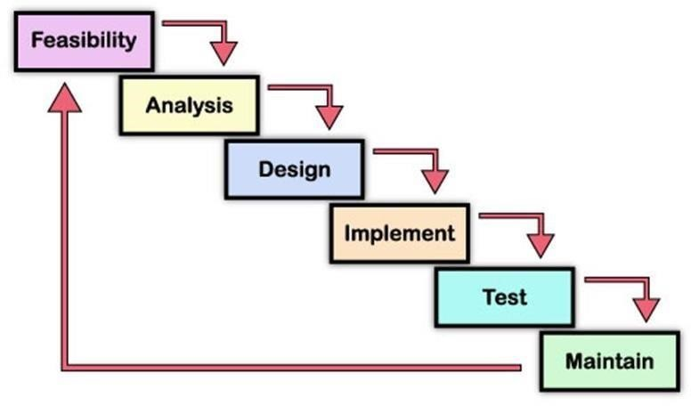

( Waterfall Model )

**Planning**

The purpose of this phase is to determine the best solution and steps taken to develop

the system. Planning involves the details planning for the timing of the working progress and types of technique will be taken next. Planning also involves that the methodology that will going to use for this project.

##### **Requirement Analysis**

The purpose of this phase is to build logical model of this system. In addition, this phase also needed to understand the applications, fact finding technique like document reviews, surveys,

observations, and sampling must be made to identify application requirement, software requirement and hardware requirement. In this phase, what kind of data requirement and the functional requirement will been decide.

##### **Design**

This phase will produce draft of the system architecture and the prototype of the application that will satisfy all requirement analysis. At this phase the user interface and all necessary input and process will be identify. This phase also determine the application

architecture, which is going to shows how to transform the logical design into basic system coding to generate the first prototype of the system. The result for this phase application interface and

system design specification. For this project, the design will be created using the Java Net beans.

##### **Implementation**

During this implementation phase, the system will be constructed. All codes are generated inside this phase. At the end of this phase, system should running and most of the function for the system should be able to use. Based from the previous phase, from the prototype, the system will become the first version inside this phase.

##### **Testing**

This phase will evaluate or verify the system that was developed. This phase will have a simulation data which will simulate the true database for the system. This is to test the functionality of the system in comparing a capture data with a database. Besides, all the functionality that may cause errors or problems to the system must be specified inside this phase because, the final result of the system is a very high priority and important. However, the testing phase will only cover to overcome the problem statement and the system objectives.

##### **Maintenance**

Various problems can arise in a client environment. Patches are published to address certain problems. Additionally, improved versions of the product are issued. To bring about these changes in the surroundings of the consumer, maintenance is performed.

#### **IMPLEMENTATION**

**TEST APPROACHES:**

Testing will be developed by series of tests in the test plan. The test plan should address all products that are created during the development of the system. The test plan will be divided to the following stages; each stage will have differently testing approaches itself:

**Unit Testing:**

Unit tests will focus on a single unit – the class. And the testers will check whether the class meets the requirements stated in the specifications or not. Unit test got 2 different approaches:

**Black – Box Testing:**

The black – box testing will be used for normal unit testing. Each class represents an encapsulated object, treated class as “black – box”. Back – box testing is driven by the CRC cards, behavioral state machines, class diagrams, contracts associated with a class, not by the programmers’ interpretation.

**White – Box Testing:**

The white – box testing is based on the method specifications associated with each class. This testing approach looks inside the class to test the code itself and its other major elements. The tester will use the white – box when the complexity is too high.

In our system, for testing unit, we decided to choose the Black – Box Testing. The reason for this decision is because of our system is not really complexity. It is simple with some functions which easy to understand. And our documentation did some kinds of diagrams already, such as CRC cards, class diagrams.

**Integration Testing:**

Integration tests assess whether a set of classes that must work together do so without error. They ensure that the interfaces and links between different parts of the system work properly. Integration tests will focus the flow of control among the classes and on the data exchanged among them.

**User Interface Testing:**

The testing is done for normal integration testing, done by moving through each and every menu item in the interface either in a top – down or bottom – up manner. The testers will test each interface function, based on the interface design sources.

**TEST CASES:**

##### **Test Case ID: 1**

Function to be tested:

Register Test Description:

To register a user Test Date:

25/07/24

Tester: TESTER NAME..

Test Objective: To ensure new user can register as member Test Execution:

1. Launch the application.
2. Enter ID
3. Enter Password
4. Mobile Number
5. Category
6. Click Save button.

Expected Result: User will be successfully registered. Actual Result: Pass

OUTPUT SNAPSHOTS :-

**MODULE SNAP:**

This section contains some Screenshots of the components of the system.

**Sign-Up screen that allows student to signup to the system:-**

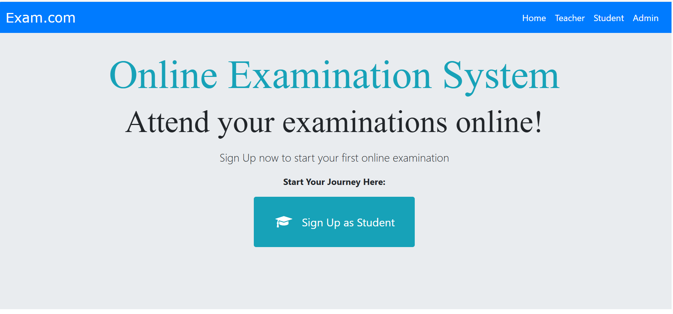

**Teacher signup form:**

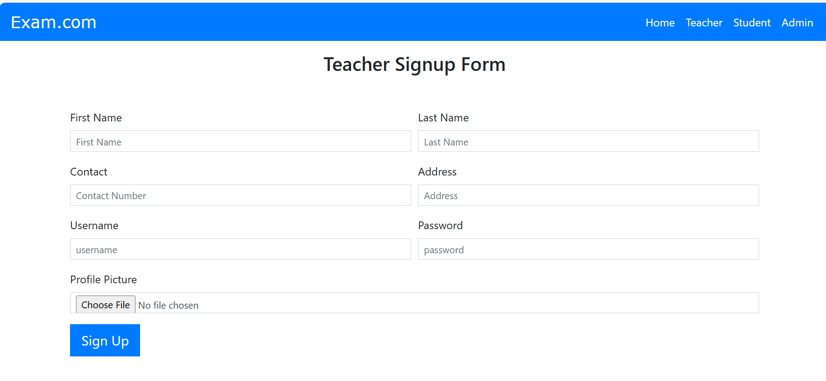

**Student Signup Form:**

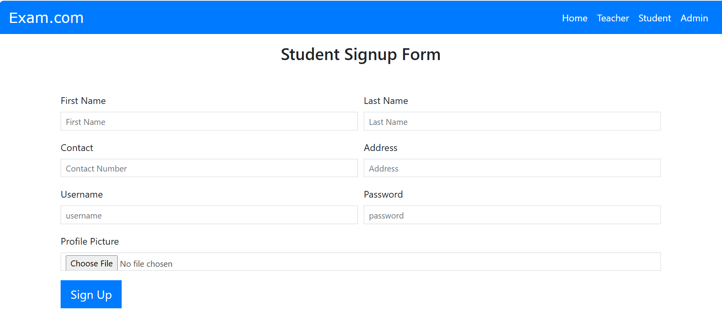

**Admin login panel:**

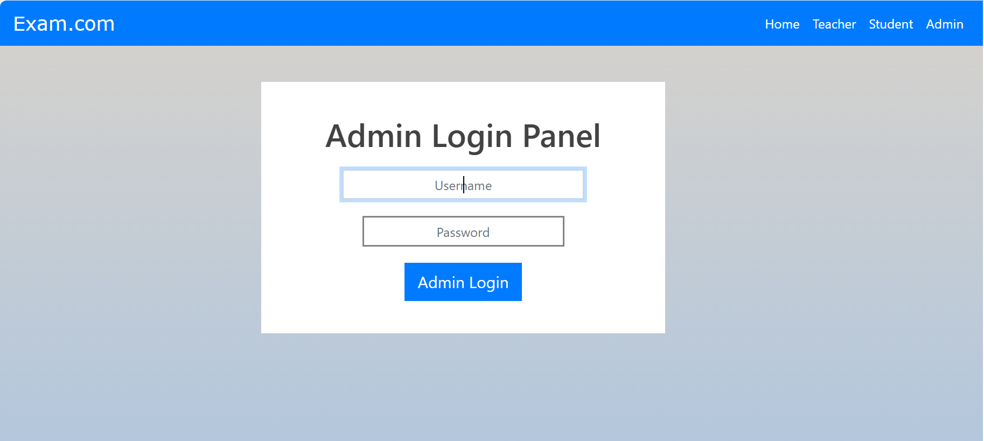

**Admin Dashboard:**

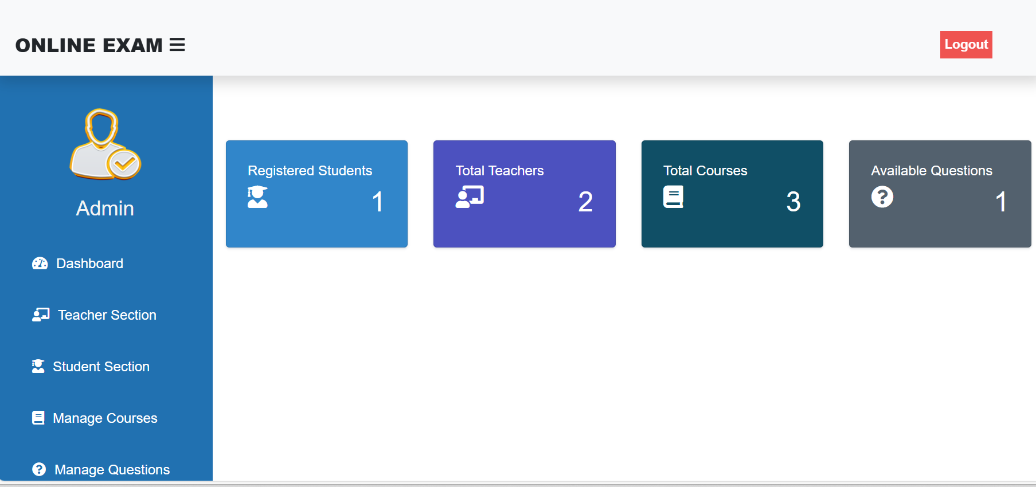

#### **CONCLUSIONS AND FUTURE WORKS**

**CONCLUSIONS:**

With the completion of this project, I conclude that it has achieved its purpose. The whole project provides a base for students to take their exam using software and allow lecturers to add questions and answers into the system. The system is developed using python programming language and data are saved in the database.

Online examination system is the best compared to paper-based exam. The automated system helps students and lecturers to save time and makes the process faster. It saves space since answers papers will not be used. With a user-friendly system that has security, integrity and the database is neither inconsistent nor redundant.

**FUTURE WORKS:**

The project has been accomplished and an application was developed to solve the afore mentioned problems. For further development, there are some recommendations on this project:

The application should support an automated time setting to let the student know how many hours and minutes are left for them to complete the examination.